**Working with Variables**

**Step 1**

**Task Instructions**

In this activity, you will define a variable within a JavaScript function. You'll learn more about functions later. For now, we'll focus on variables.

**To accomplish this task, you need to do the following:**

Open the Variables-01 folder and add code to the variables01.js file to do the following:

* Create a variable called myFriend using one of the variable declarations described above.
* Set the variable you created to contain your friend's name.
* Inside the greetings function, return the string: "Greetings [your-friend's-name]."

*Note: The following line of code console.log('results: ', greetings()); will print the result of your code to the console. You will learn more about how this works later on in the course.*

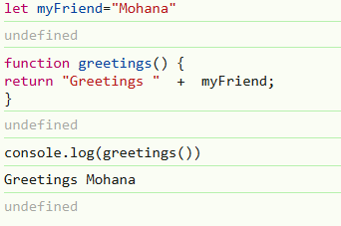

**Working with Variables**

**Step 2**

#### Task Instructions

Your task in this activity is to declare a variable named currentYear using let. This variable should have the current year as a value (ex. 1991).

*Note: This line of code console.log('current year result: ', currentYear); will print the value of your variable to the console.*

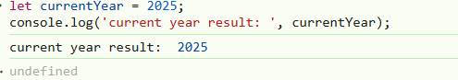

**Working with Variables**

**Step 3**

**Task Instruction**

In this activity, you will declare variables with let and const keywords. The function testBestFlavor needs to print the message: "Ana says, lacroix orange is a better flavor than lacroix grapefruit."

To make this function complete, you need to declare two constants:

* lacroix1: This needs to be declared **outside** the scope of the function testBestFlavor using const and it needs to have the value "grapefruit".
* lacroix2: This needs to be declared **inside** the scope of the function testBestFlavor using const and it needs to have the value "orange".

